**VISVESVARAYA TECHNOLOGICAL UNIVERSITY**

**“JnanaSangama”, Belgaum -590014, Karnataka.**



**LAB RECORD**

**Computer Network Lab (23CS5PCCON)**

***Submitted by***

**Dyuthi (1BM23CS097)**

***in partial fulfillment for the award of the degree of***

**BACHELOR OF ENGINEERING**

***in***

**COMPUTER SCIENCE AND ENGINEERING**



**B.M.S. COLLEGE OF ENGINEERING**

# (Autonomous Institution under VTU)

**BENGALURU-560019**

**Academic Year 2025-26 (even)**

B.M.S. College of Engineering

**Bull Temple Road, Bangalore 560019**

(Affiliated To Visvesvaraya Technological University, Belgaum)

**Department of Computer Science and Engineering**



**CERTIFICATE**

This is to certify that the Lab work entitled “ Computer Network (23CS5PCCON)” carried out by **Dyuthi (1BM23CS097),** who is bonafide student of **B.M.S. College of Engineering.** It is in partial fulfilment for the award of **Bachelor of Engineering in Computer Science and Engineering** of the Visvesvaraya Technological University, Belgaum. The Lab report has been approved as it satisfies the academic requirements of the above-mentioned subject and the work prescribed for the said degree.

|  |  |
| --- | --- |
| Sarala D V  Assistant Professor Department of CSE, BMSCE | Dr. Selva Kumar Professor & HOD  Department of CSE, BMSCE |

**Index**

|  |  |  |  |
| --- | --- | --- | --- |
| **Sl.**  **No.** | **Date** | **Experiment Title** | **Page No.** |
| 1 | 13-08-2025 | Simple PDU from source to destination using hub and switch as connecting devices. | 4-8 |
| 2 | 17-09-2025 | Default route and static route to the Router | 9-13 |
| 3 | 03-09-2025 | DHCP within a LAN and outside LAN | 14-15 |
| 4 | 10-09-2025 | Web Server, DNS within a LAN | 16-18 |
| 5 | 08-10-2025 | Operation of TELNET to access the router in server room from a PC in IT office | 19-21 |
| 6 | 19-11-2025 | RIP routing Protocol in Routers | 22-23 |
| 7 | 15-10-2025 | VLAN to make the PCs communicate among a VLAN | 24-25 |
| 8 | 15-10-2025 | WLAN to make the nodes communicate wirelessly | 26-27 |
| 9 | 19-11-2025 | Simple LAN to understand the concept and operation of ARP | 28-29 |
| 10 | 08-10-2025 | OSPF routing protocol | 30-31 |
| 11 | 15-10-2025 | TTL/ Life of a Packet | 32-33 |
| 12 | 15-10-2026 | Ping responses, destination unreachable, request timed out, reply | 34-36 |
| 13 | 29-10-2025 | Congestion control using Leaky bucket algorithm | 37-38 |
| 14 | 29-10-2025 | Error detecting code using CRC-CCITT | 39-40 |
| 15 | 12-11-2025 | TCP File Request–Response Using Client–Server Socket Program | 41-42 |
| 16 | 12-11-2025 | UDP File Request–Response Using Client–Server Socket Program | 43-44 |

GithubLink: https://github.com/GayathriS-CSE/CN-LAB

# CYCLE 1:

**Program 1**

Aim of the program:

Create a topology and simulate sending a simple PDU from source to destination using hub and switch as connecting devices and demonstrate ping message.

Procedure and topology:

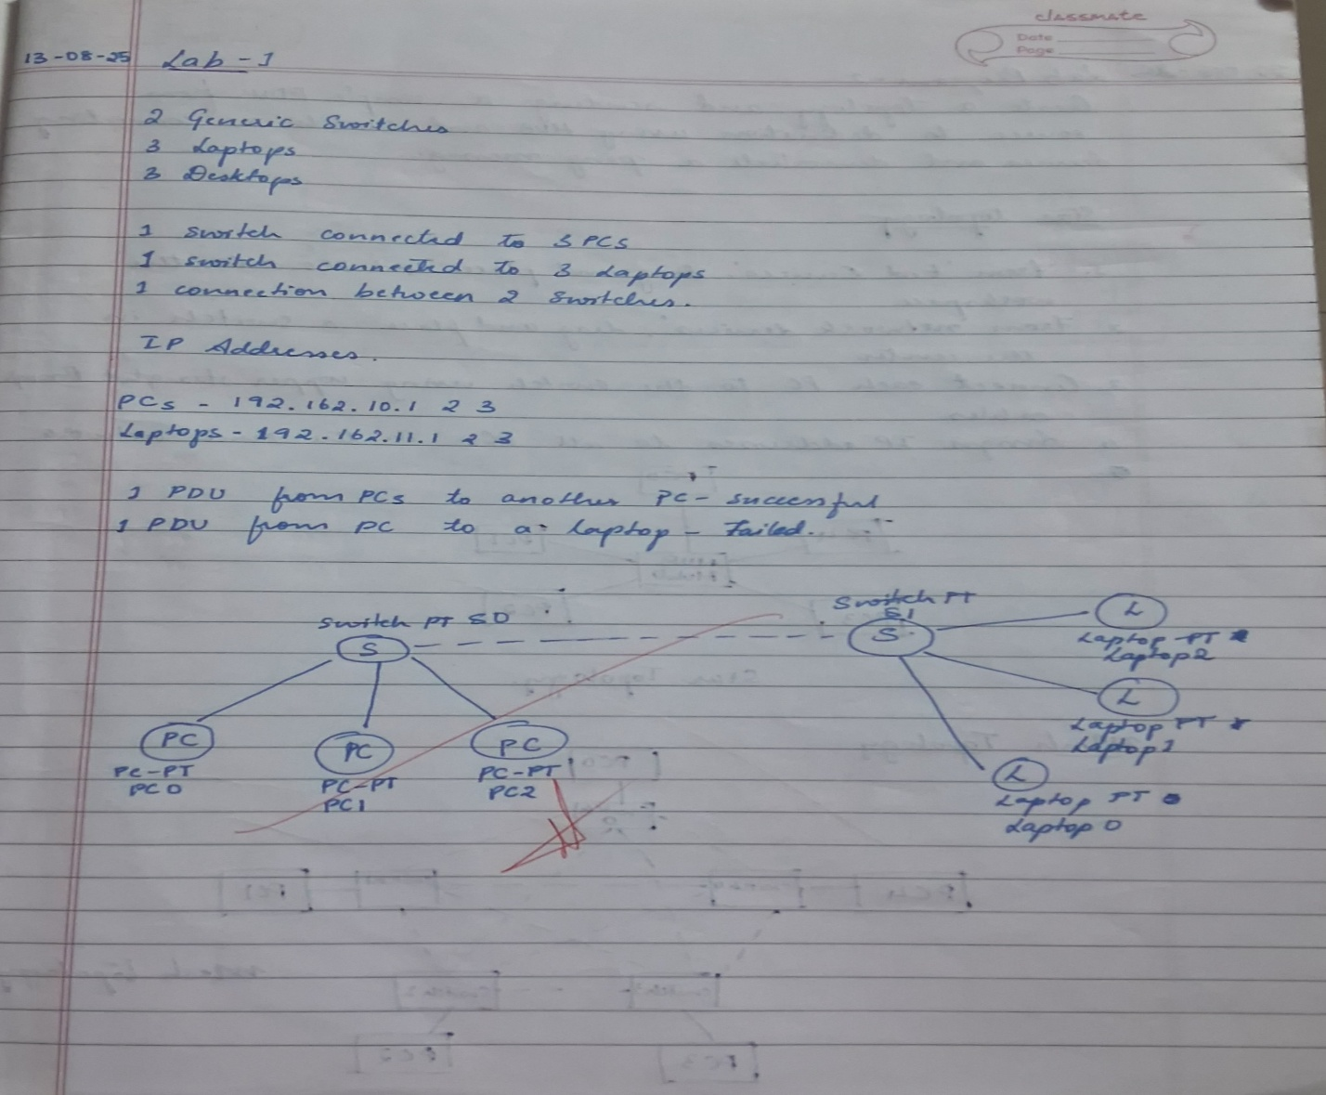

Screenshots/ Output:

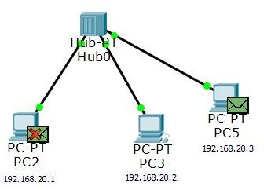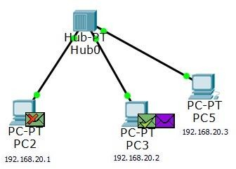

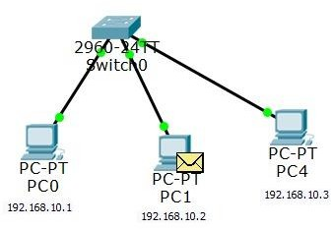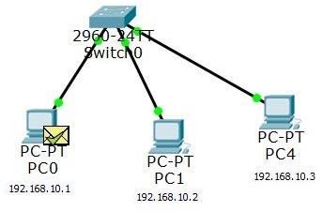

Updated topology

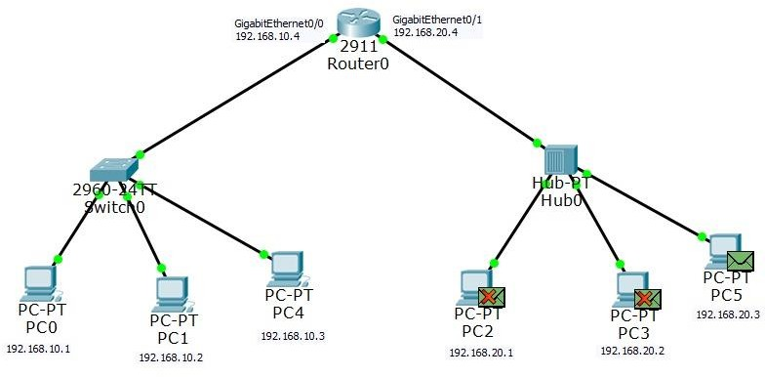

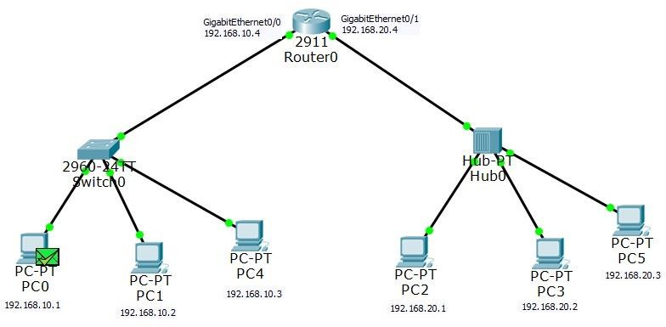

Observation:

* In the hub-based topology, the PDU was broadcast to all ports, while the switch forwarded the PDU only to the destination MAC after learning addresses from incoming frames.
* Successful ICMP echo and echo-reply messages confirm that both devices enabled connectivity, with the switch demonstrating selective unicast forwarding and reduced unnecessary traffic.

# Program 2

Aim of the program:

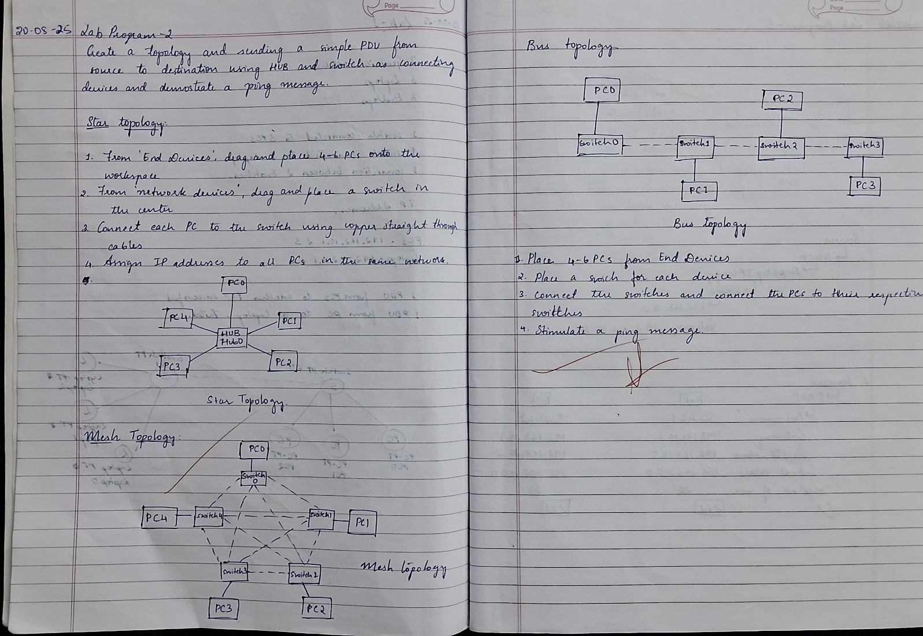Configure default route, static route to the Router Procedure and topology:

Screenshots/ Output:

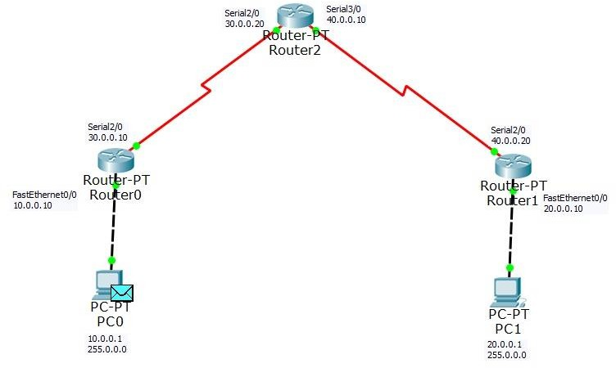

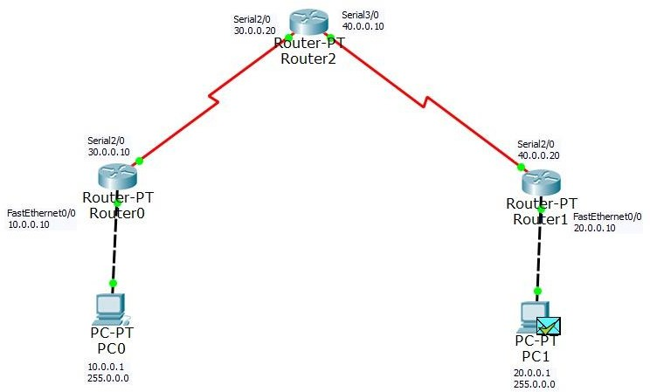

Static routing CLI commands:

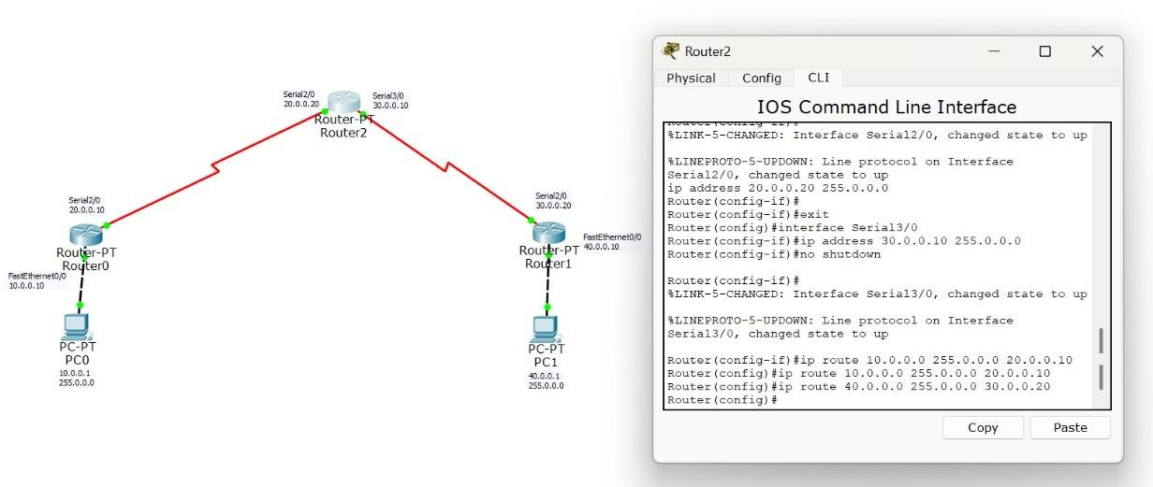

Default routing CLI commands:

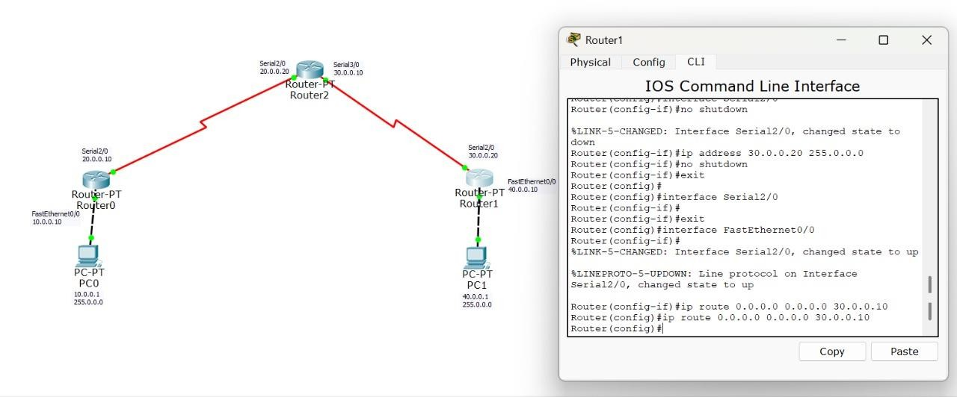

Observation:

* The configured static and default routes correctly updated the router’s routing table, enabling

deterministic next-hop selection for remote networks.

* Successful ping tests verified that traffic was forwarded according to the static/default route entries, ensuring end-to-end reachability across different network segments.

# Program 3

Aim of the program:

Configure DHCP within a LAN and outside LAN. Procedure and topology:

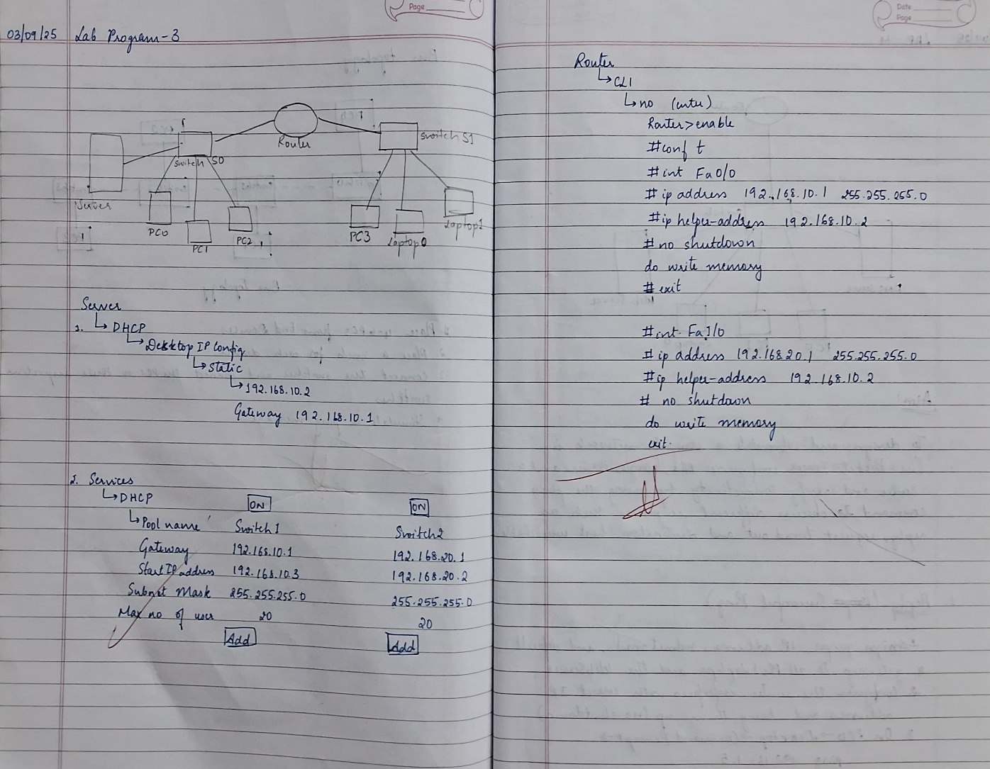

Screenshots/ Output:

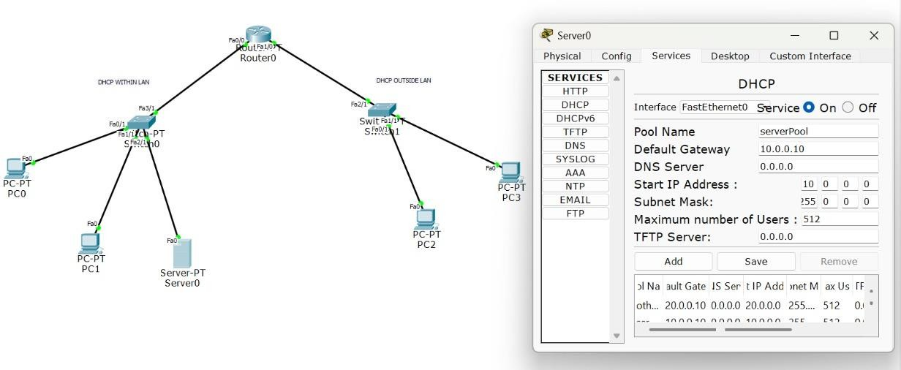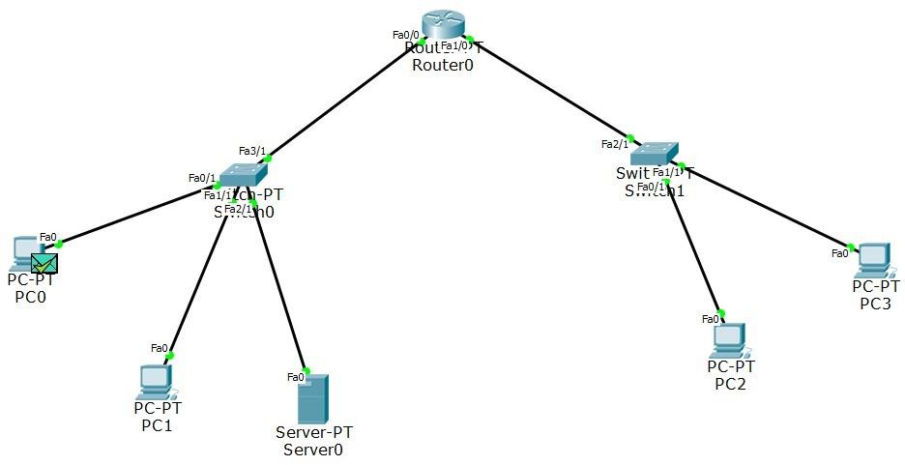

Observation:

* The DHCP server successfully allocated IP addresses to clients within the LAN, confirming proper scope configuration and automatic distribution of network parameters.
* DHCP relay (IP Helper) enabled clients outside the LAN to obtain leases from the central DHCP server, demonstrating correct inter-network forwarding of DHCP Discover and Offer messages.

# Program 4

Aim of the program:

Configure Web Server, DNS within a LAN. Procedure and topology:

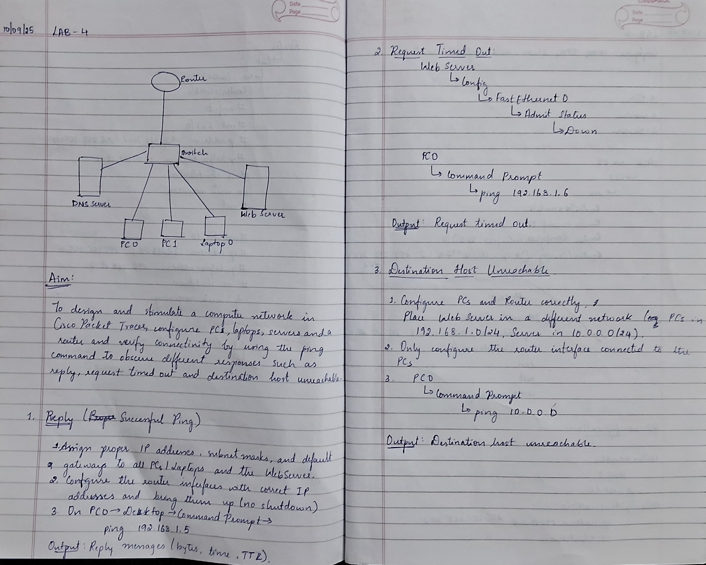

Screenshots/ Output:

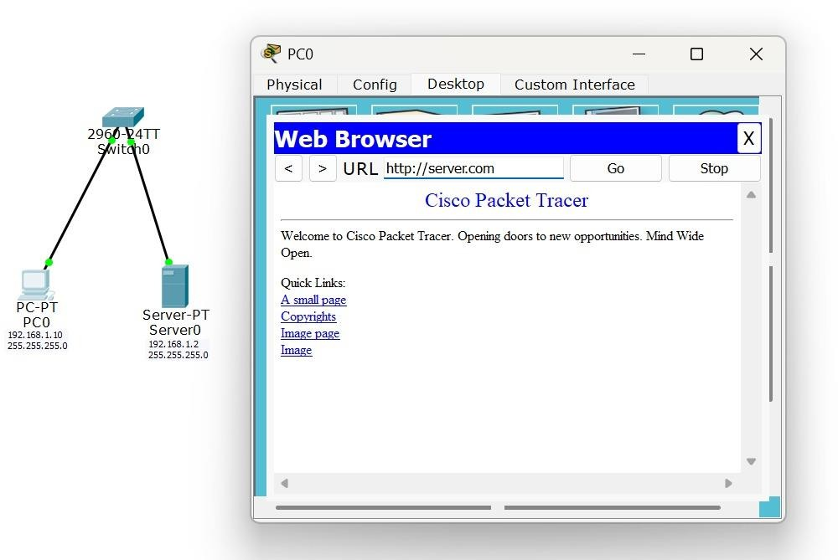

Observation:

* The DNS server successfully resolved domain names to the corresponding web server’s IP

address, confirming proper hostname-to-IP mapping within the LAN.

* HTTP requests reached the web server using the DNS-resolved address, validating correct server configuration and internal LAN communication.

# Program 5

Aim of the program:

To understand the operation of TELNET by accessing the router in server room from a PC in IT office

Procedure and topology:

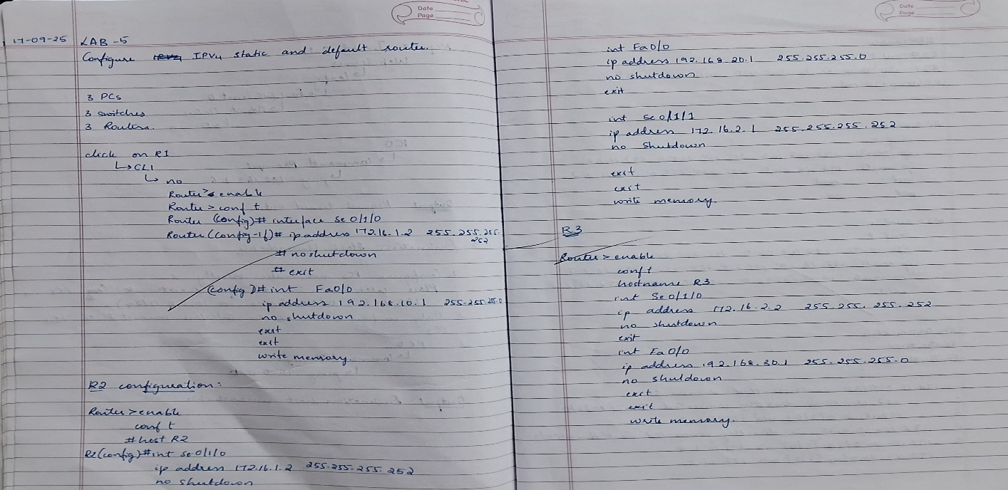

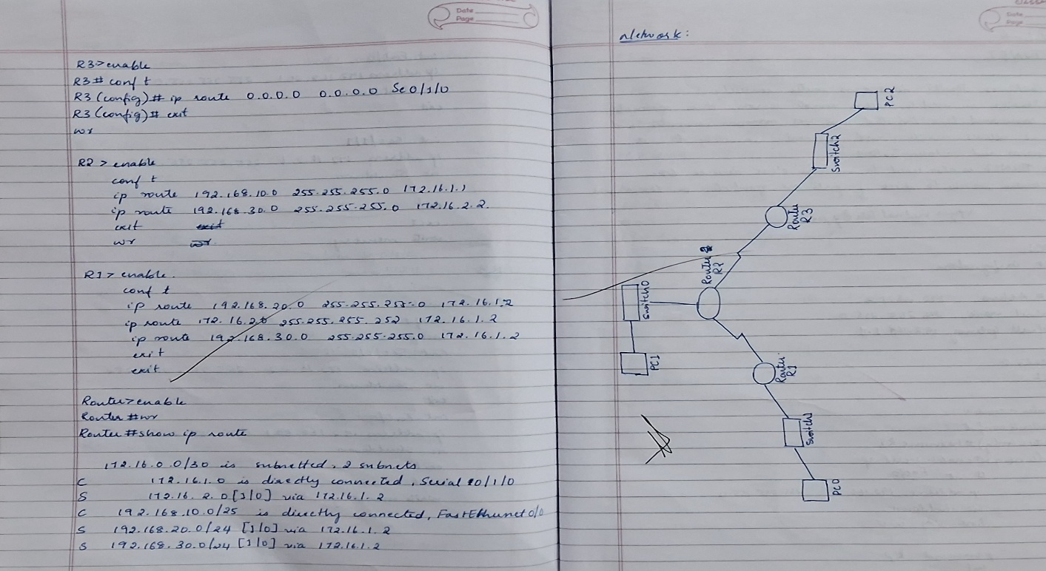

Screenshots/ Output:

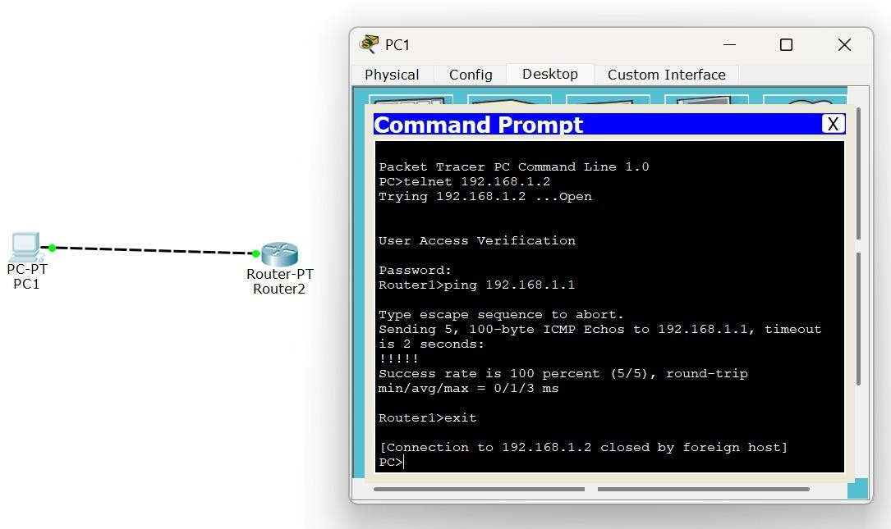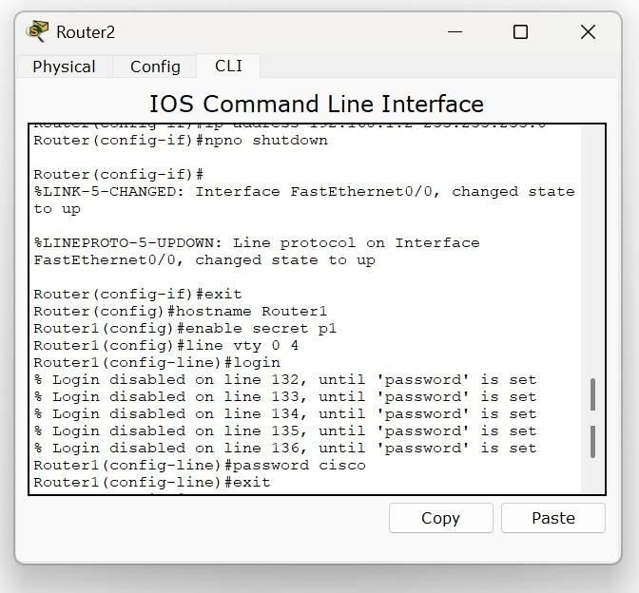

Observation:

* The Telnet session successfully established a remote CLI connection to the router, confirming proper VTY line configuration and IP reachability between the IT office PC and the server room router.
* Command execution over the Telnet session demonstrated reliable remote device management.

# Program 6

Aim of the program:

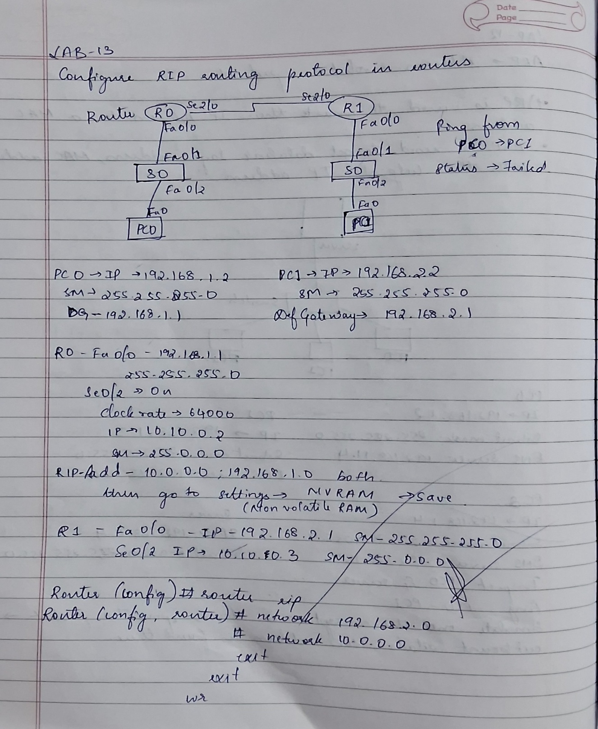Configure RIP routing Protocol in Routers Procedure and topology:

Screenshots/ Output:

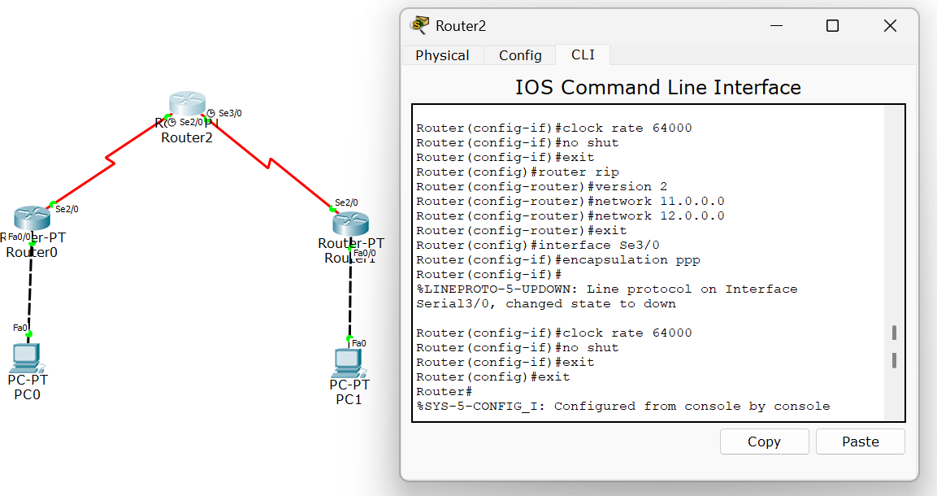

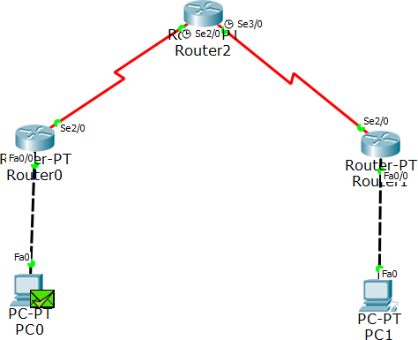

Observation:

* RIP routing updates were successfully exchanged between routers, allowing each router to dynamically learn remote network routes through hop-count–based distance vector advertisements.
* The routing tables converged correctly, and successful ping tests confirmed end-to-end connectivity maintained by periodic RIP updates and route propagation.

# Program 7

Aim of the program:

To construct a VLAN and make the PCs communicate among a VLAN Procedure and topology:

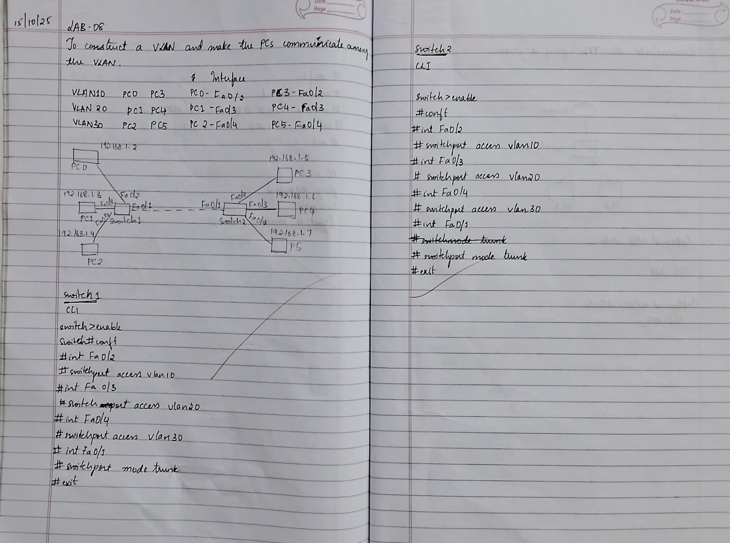

Screenshots/ Output:

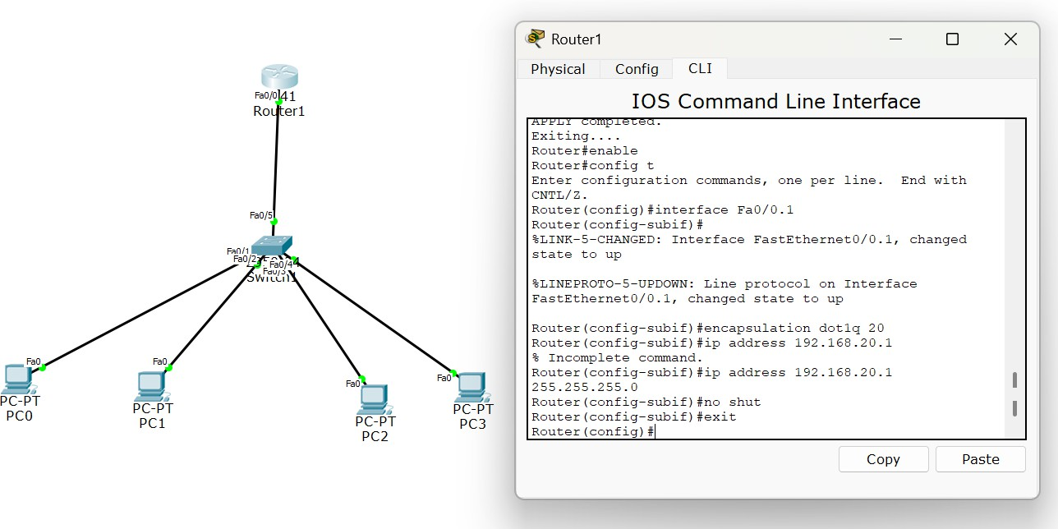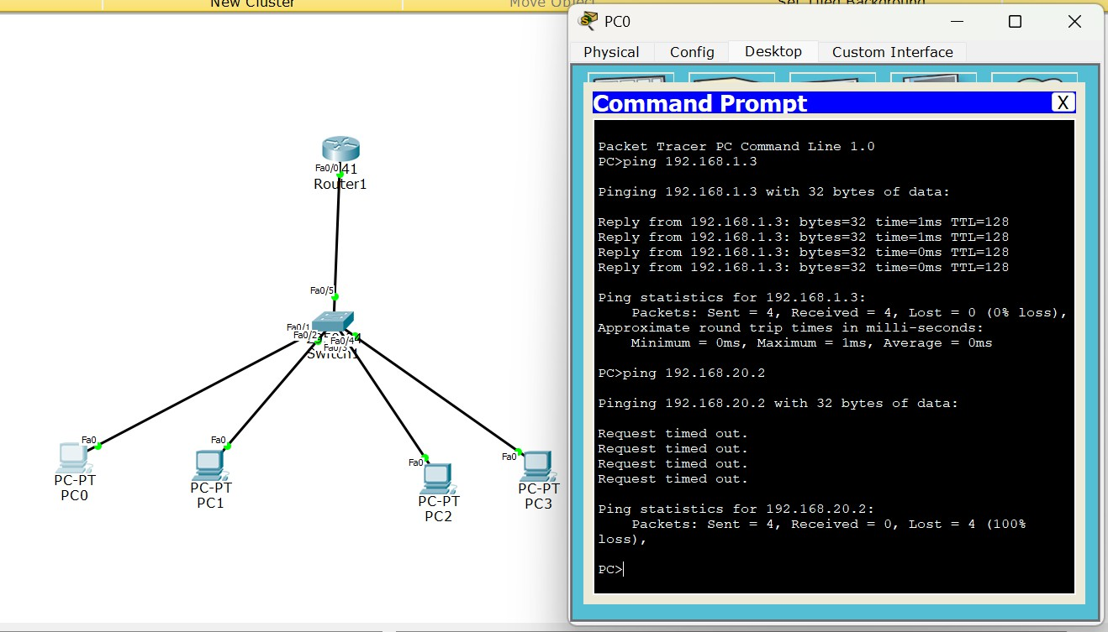

Observation:

* VLAN segmentation successfully separated broadcast domains, and switch ports were correctly assigned to their respective VLAN IDs using access mode configuration.
* Inter-VLAN communication was achieved through the Layer-3 device, and successful ping tests confirmed proper VLAN membership, tagging, and routing functionality.

# Program 8

Aim of the program:

To construct a WLAN and make the nodes communicate wirelessly Procedure and topology:

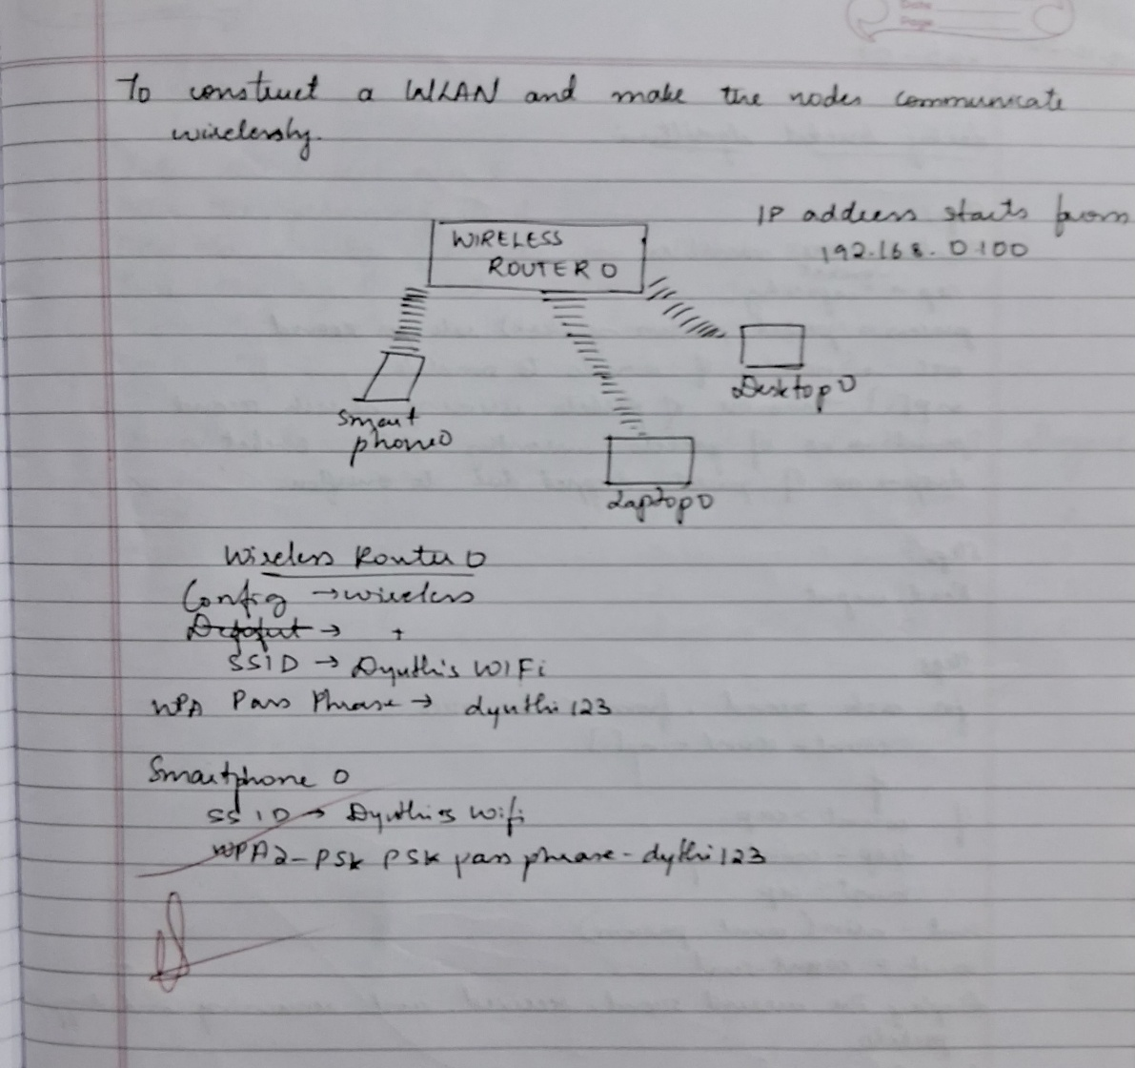

Screenshots/ Output:

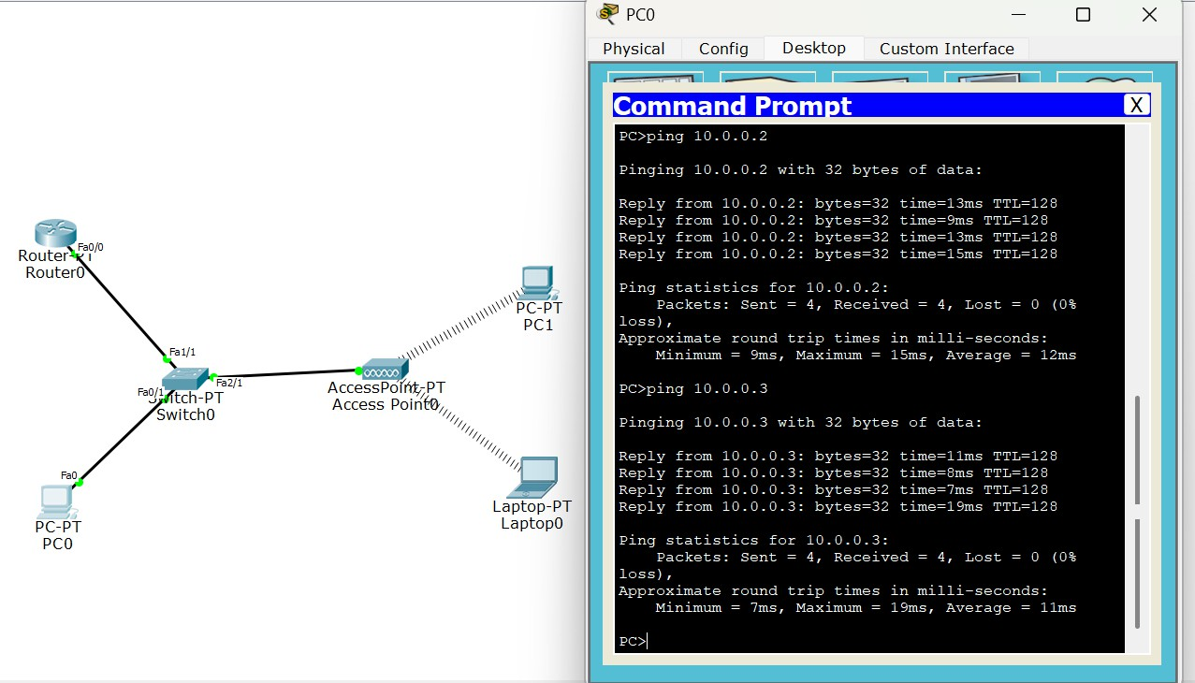

Observation:

* The WLAN configuration enabled wireless nodes to associate with the access point using the configured SSID and security settings, confirming proper authentication and signal coverage.
* Successful ping communication between wireless devices verified stable wireless Connectivity.

# Program 9

Aim of the program:

To construct simple LAN and understand the concept and operation of Address Resolution Protocol (ARP)

Procedure and topology:

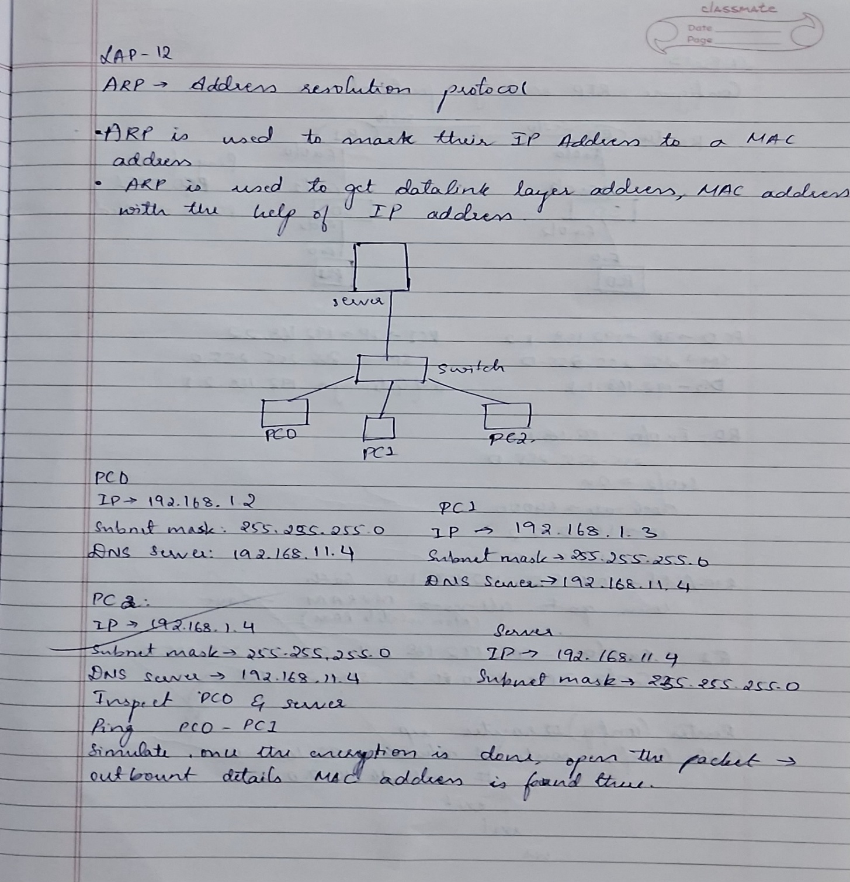

Screenshots/ Output:

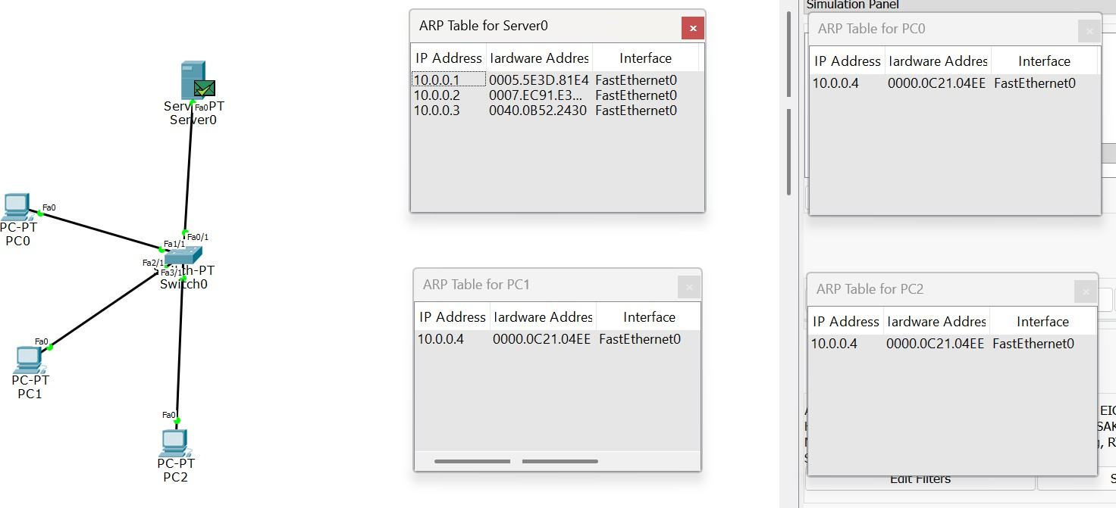

Observation:

* ARP successfully resolved the destination IP address to its corresponding MAC address, as seen from ARP request and reply exchanges between LAN hosts.
* The populated ARP tables and successful ping communication confirmed correct layer-2 addressing, frame forwarding, and basic LAN operation.

# Program 10

Aim of the program:

Configure OSPF routing protocol Procedure and topology:

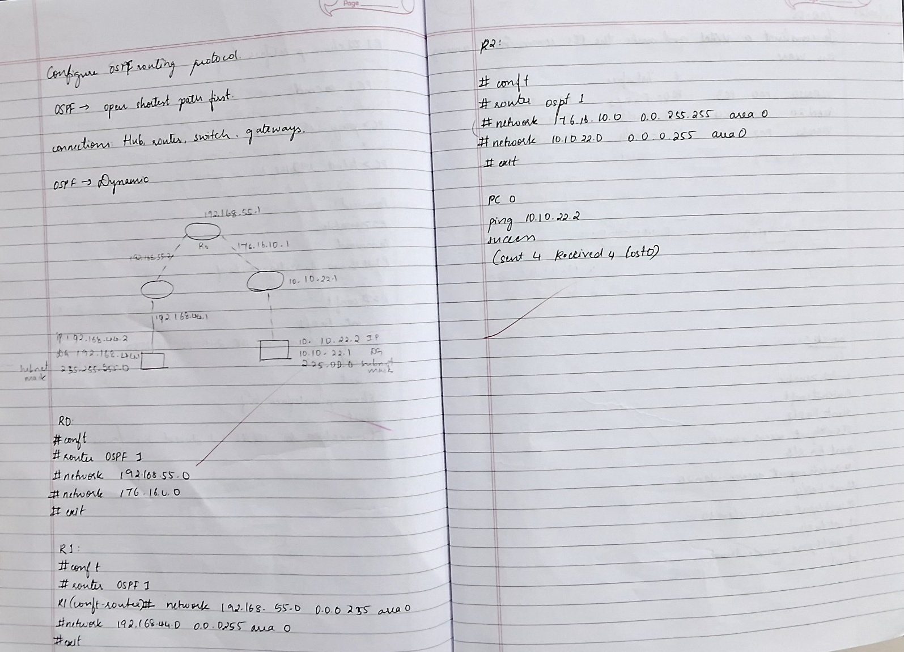

Screenshots/ Output:

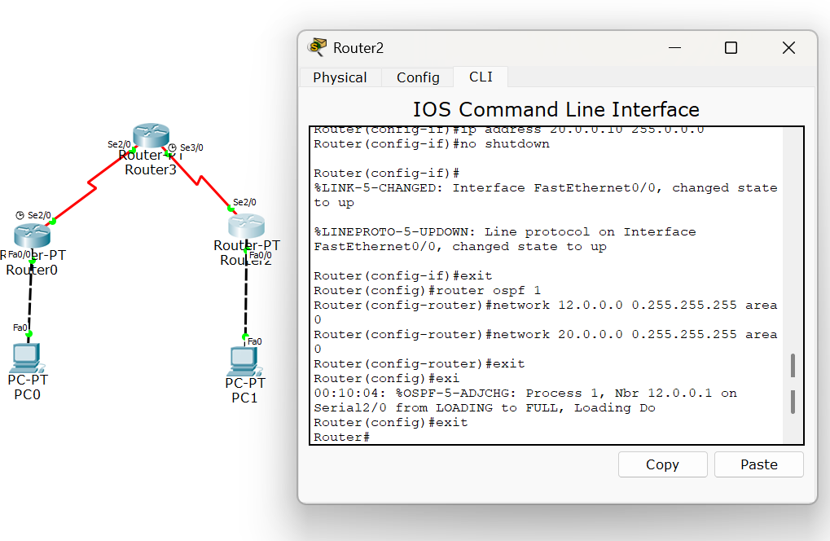

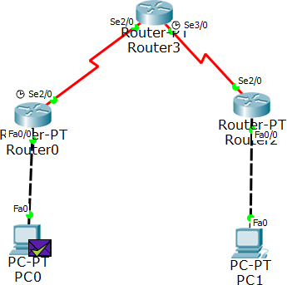

Observation:

* OSPF successfully established neighbour adjacencies and exchanged LSAs, allowing routers to build a synchronized link-state database across the OSPF area.
* The routing tables converged using SPF calculations, and successful pings confirmed efficient path selection and dynamic route learning through OSPF.

# Program 11

Aim of the program:

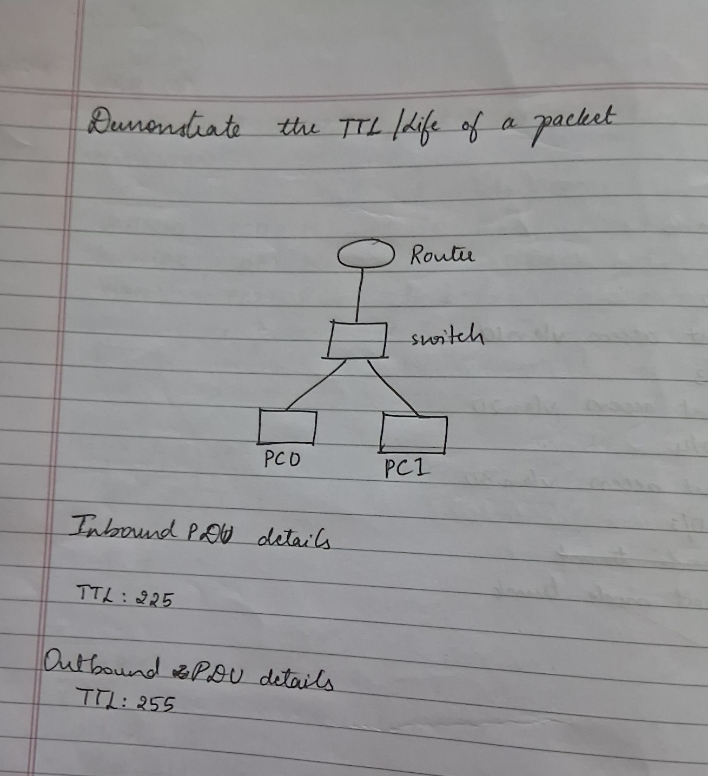Demonstrate the TTL/ Life of a Packet Procedure and topology:

Screenshots/ Output:

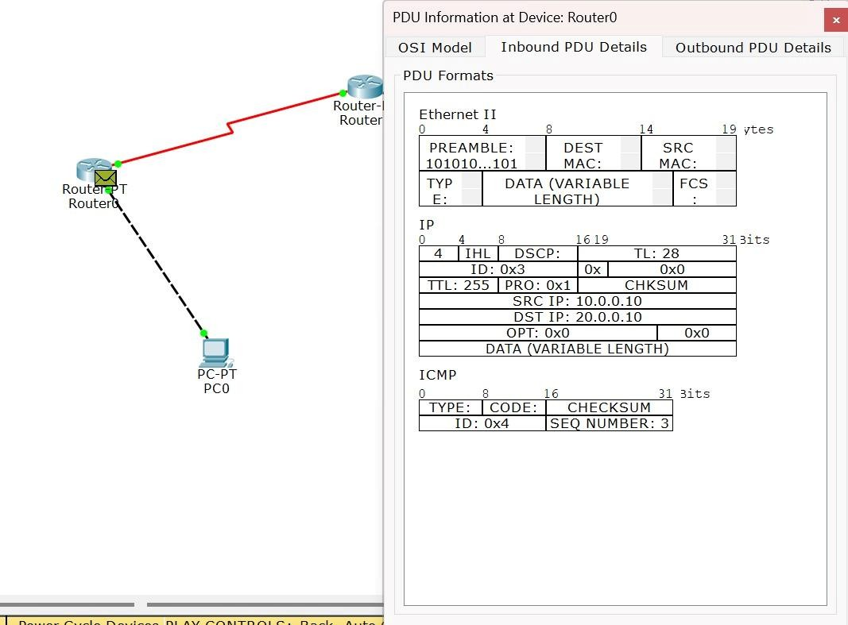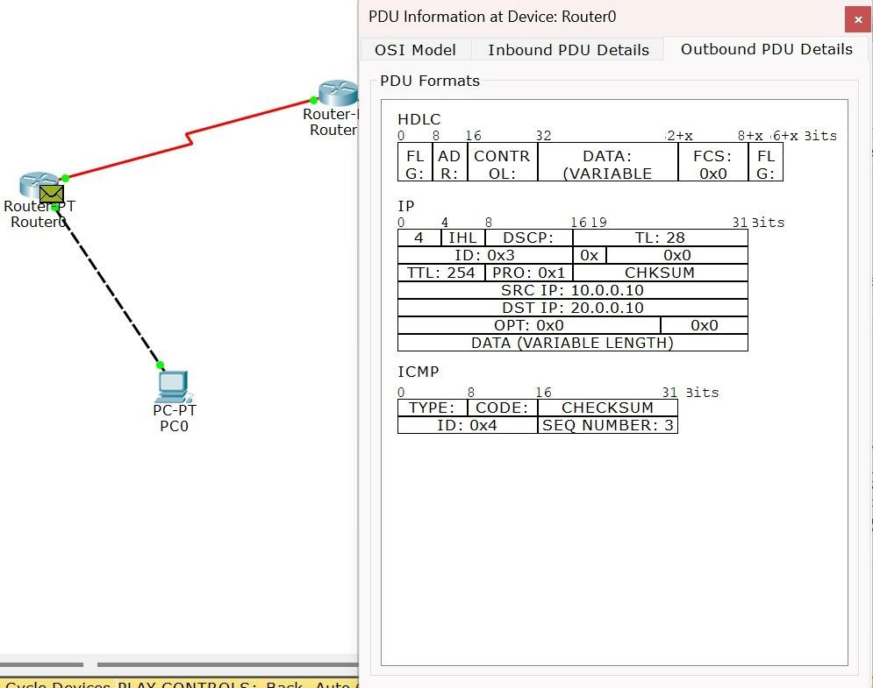

Observation:

* The TTL field in the IP header decreased by one at each router hop, demonstrating its role in preventing packets from looping indefinitely in the network.

# Program 12

Aim of the program:

Configure IP address to routers in packet tracer. Explore the following messages: ping responses, destination unreachable, request timed out, reply

Procedure and topology:



Screenshots/ Output:

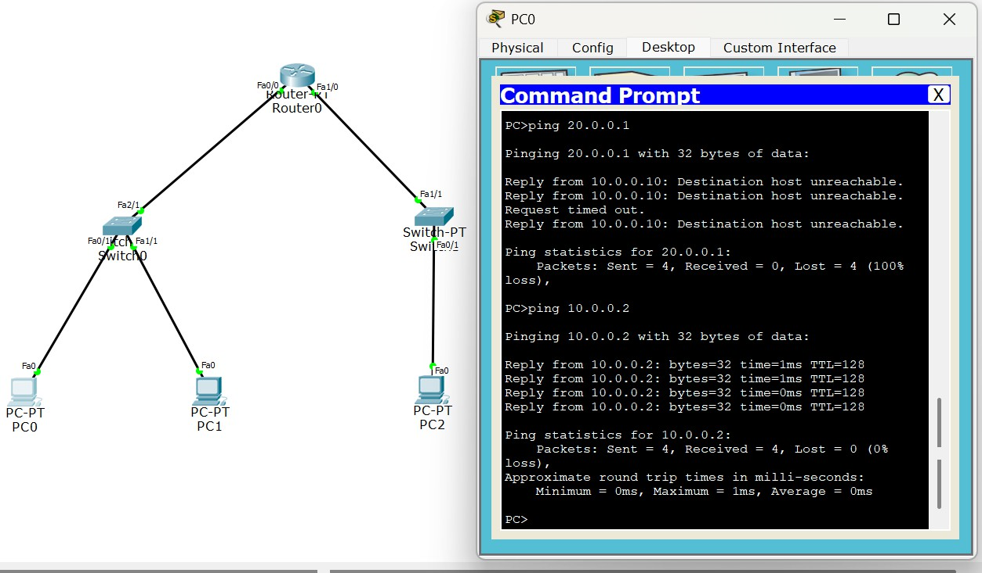

Observation:

* Proper IP addressing on router interfaces enabled successful ICMP echo and echo-reply communication, confirming correct Layer-3 configuration and reachability.
* “Destination Unreachable” and “Request Timed Out” responses occurred when routes or interfaces were misconfigured, demonstrating how routers handle missing paths and non- responsive hosts.

# CYCLE 2:

**Program 13**

Aim of the program:

Write a program for congestion control using Leaky bucket algorithm Procedure and topology:

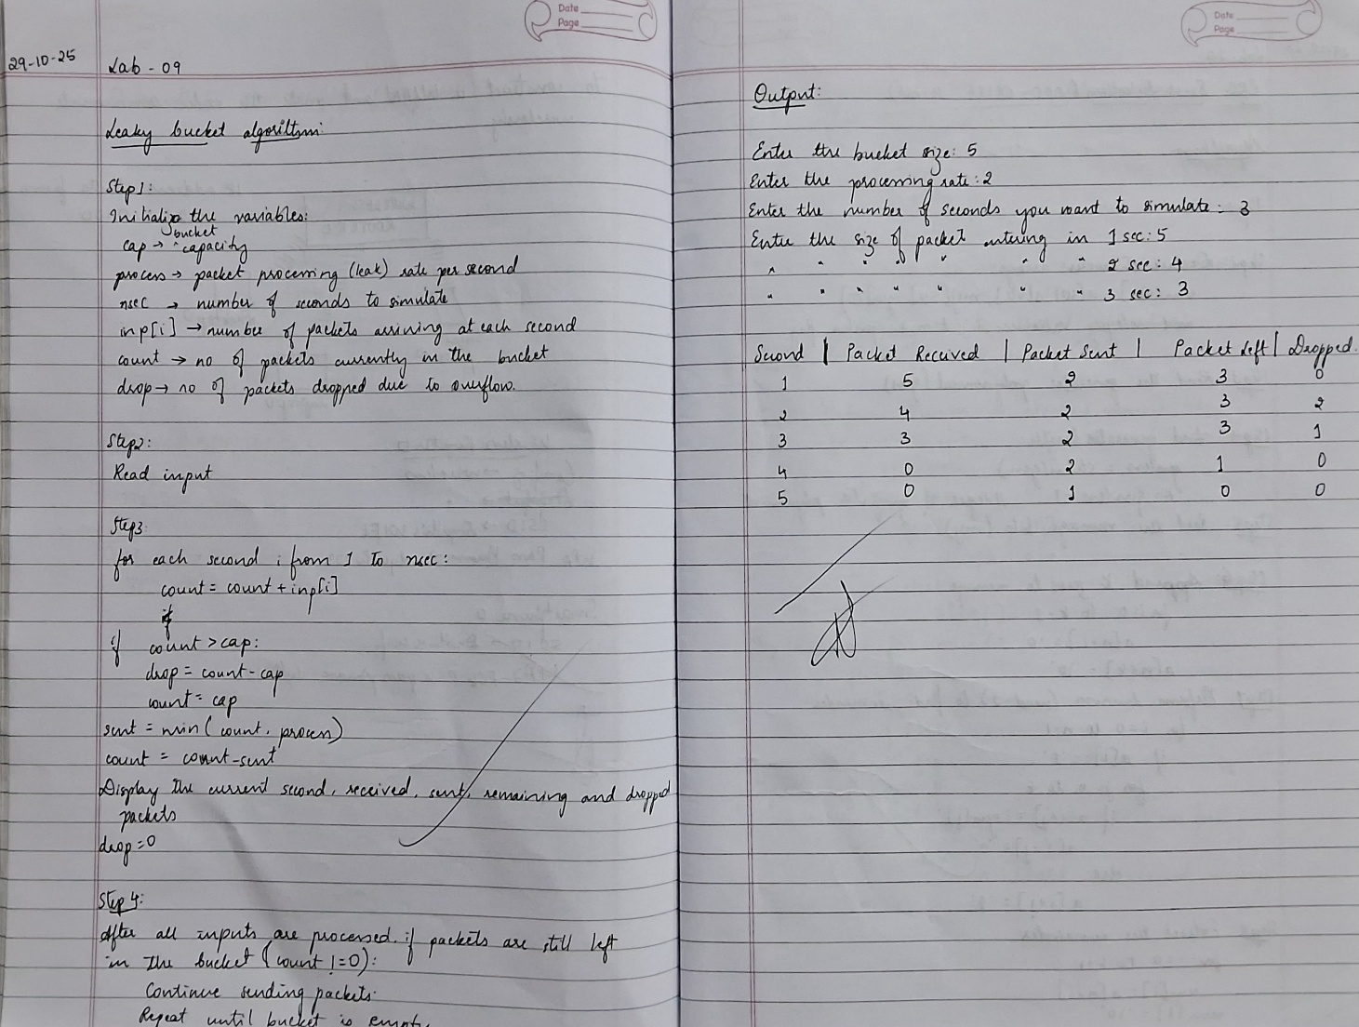

Screenshots/ Output:

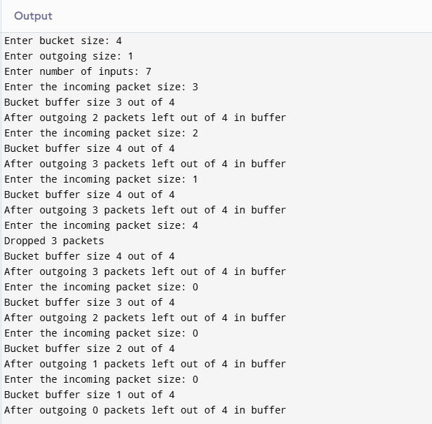

Observation:

* The leaky bucket mechanism regulated the outgoing packet flow at a constant rate, preventing sudden traffic bursts from overwhelming the network.
* Packets exceeding the bucket capacity were dropped, demonstrating effective congestion control by smoothing traffic and enforcing rate-limiting.

# Program 14

Aim of the program:

Write a program for error detecting code using CRC-CCITT (16-bits). Procedure and topology:

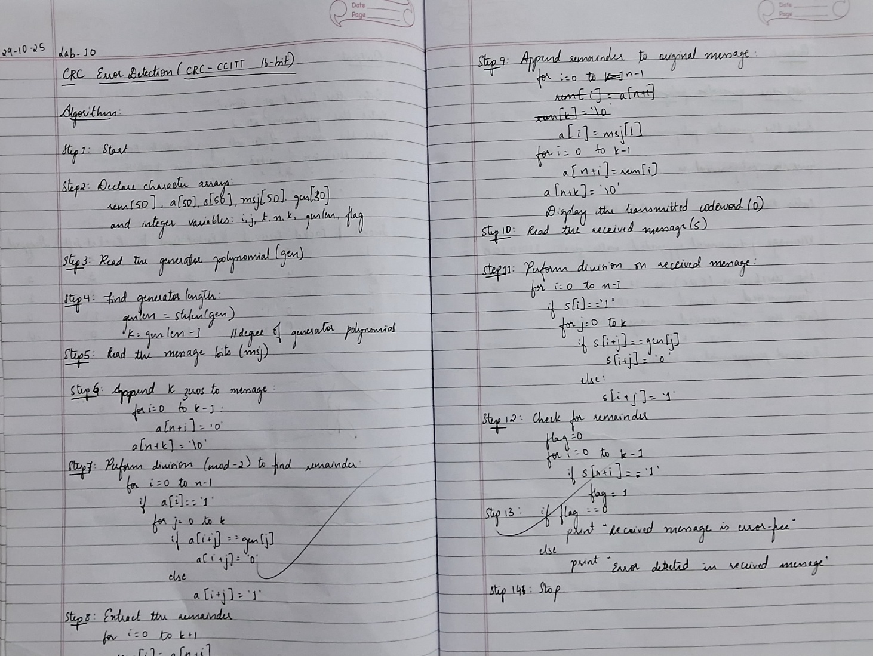

Screenshots/ Output:

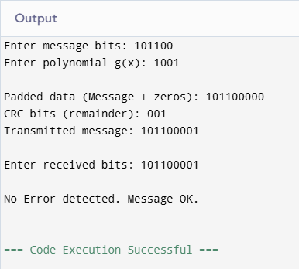

Observation:

* The CRC-CCITT (16-bit) algorithm correctly generated a checksum for the transmitted data, ensuring reliable detection of single-bit and burst errors.
* Intentional error tests produced mismatched CRC values at the receiver, confirming accurate error detection through polynomial division.

# Program 15

Aim of the program:

Using TCP/IP sockets, write a client-server program to make client sending the file name and the server to send back the contents of the requested file if present.

Procedure and topology:

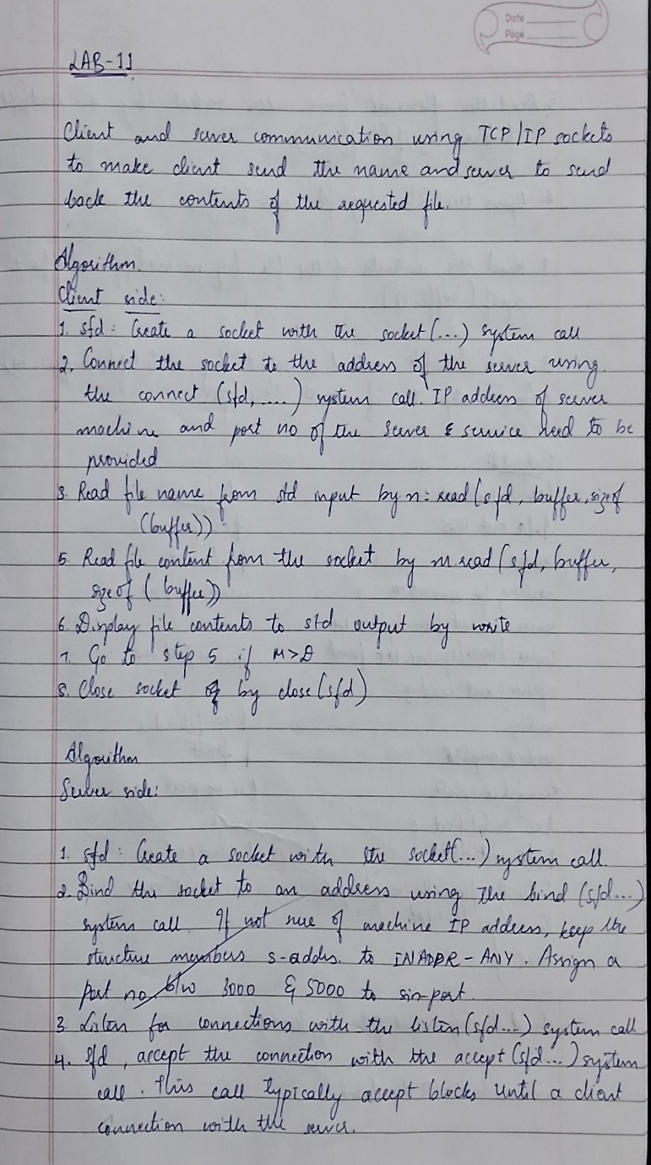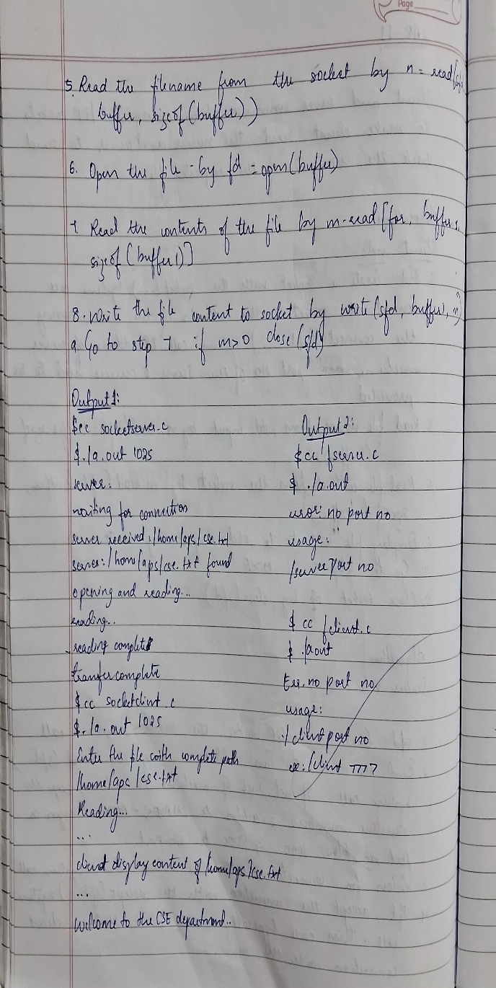

Screenshots/ Output:

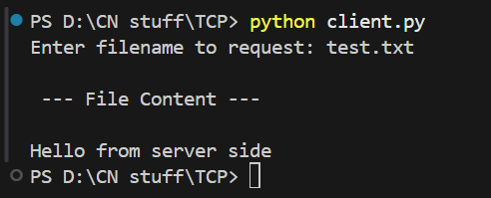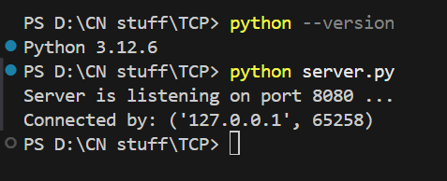

Observation:

* The TCP client successfully established a reliable connection with the server and transmitted the requested filename using stream-oriented communication.
* The server correctly retrieved and returned the file contents over the same TCP session, demonstrating reliable data transfer, acknowledgment handling, and error-free delivery.

# Program 16

Aim of the program:

Using UDP sockets, write a client-server program to make client sending the file name and the server to send back the contents of the requested file if present.

Procedure and topology:

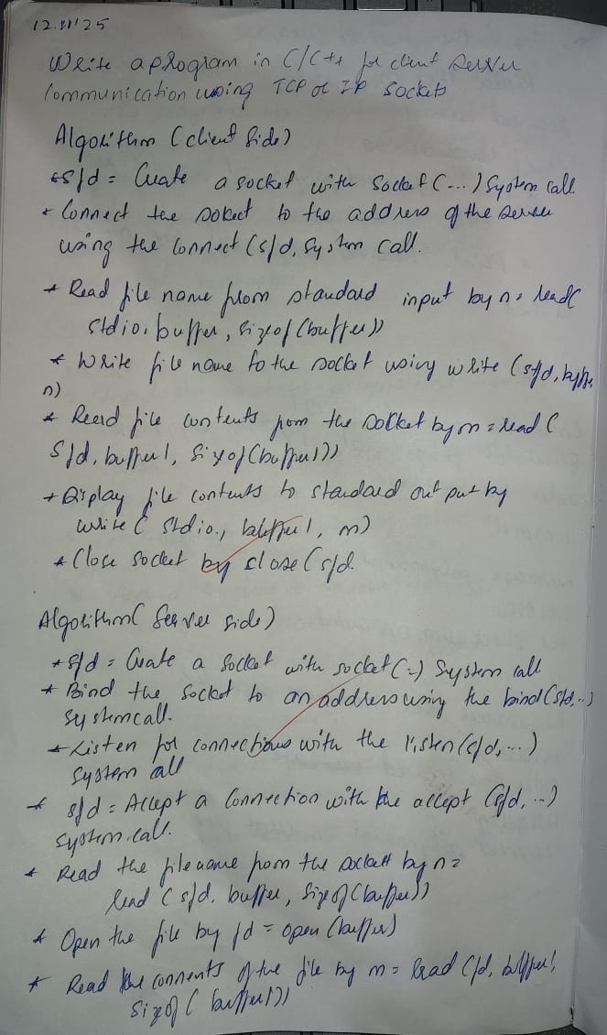

Screenshots/ Output:

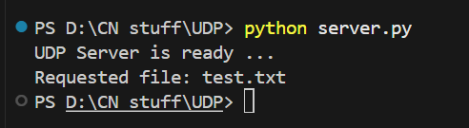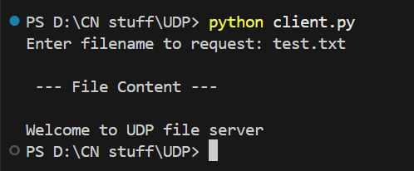

Observation:

* The UDP client successfully sent the filename as a connectionless datagram, demonstrating non-reliable, low-overhead message transfer without session establishment.
* The server responded with the file contents using UDP packets, and correct reception validated functional data exchange despite the absence of acknowledgment and retransmission mechanisms.